|  |  |
| --- | --- |
| MEMO | |
| October 7, 2015 | |
| Subject : SALE OF RULE BASED INDEX STRATEGIES TO US, CANADA AND LATIN AMERICA CUSTOMERS | |
| Direction : [CIB Global Markets]  Entity : [Equity Derivatives]  Sponsor : [Eric Le Brusq (Sales & Financial Engineering)] | |
| FROM | * [Business Management Global Markets /] |
| TO | * [NPNA team] |
| CCs | * [Muriel Leclercq] (SG GM) * Project Management (SG GM) * [Luc Francois] (Global Markets) |

|  |
| --- |
| **Activity description** |

**[Equity Markets] wishes to commercialize fully systematic strategies to customers based in USA, Canada and Latin America.**

**Strategies’ investment universe will include mostly Equities but also Hybrids, ETFs and Mutual Funds.**

**Target customers’ type will include both distribution (Private banks) and institutional (Insurance companies, Family offices, foundations, endowment,…).**

**These strategies will be embedded into rule based indices and sold through various wrappers such as Notes (Reg S and 3(a)2 ), OTC options and TRS.**

**The related rule based Indices will be sponsored and branded either by Natixis or an external Index provider (e.g. Wilshire or Standard and Poor’s)**

**Moreover, the related transactions will be booked inside FAST or Equity Finance trading books whilst the corresponding systematic strategies will be:**

1. **Booked through a dedicated module developed by the quantitative team within Sophis environment and in line with the Index rules (current set up)**
2. **scripted within Caesar Index (in accordance with the index rules) once the Caesar Index platform is live and validated by the Risk Department. Caesar Index will fuel the Sophis booking (target set up by the end of 2015).**

**This project was presented to NY EXCO on January 8 2015**

1. **Strategy and contextual items**

*1.1. Strategic positioning of the new product or new activity*

As a direct consequence of the behaviour of black boxes strategies in 2008, customers now favour simple and fully transparent investments tailored to their needs.

Systematic strategies embedded inside rule based indices deal with the major part of above investor’s concerns.

In addition, most of Natixis competitors have already been offering such systematic strategies on a worldwide basis in general and to Americas based customers in particular.

Natixis has already been granted the right to commercialize these products to customers out of the Americas region.

Natixis would like to catch up with competition, diversify its customers’ range and its sources of profitability by including the customers based in the Americas region as potential targets for an offer of tailored made systematic strategies embedded into rule based indices.

Last but not least, this new activity could enable Natixis to strengthen its Americas franchise thanks to partnerships with third parties (including but not limited to NGAM affiliate) in the context of systematic strategies design and branding.

**The purpose of this NPC is thus to allow [Equity Market] to commercialize systematic strategies embedded into rule based indices to customers based in USA, Canada and Latin America.**

As further described below, these activity is not totally new for Natixis since:

1. CNP 09-30 allowed [Equity Markets] to structure rule based indices in Europe;
2. Following the conclusions of CNP 09-30 rule based indices have already been commercialized by Natixis to customers based in Europe and Asia;
3. From an operational perspective, as a result of the above, (i) a significant number of transactions are currently being managed inside [the Hybrid book and former SED Paris book] (ii) Caesar Index platform has made significant development in order to industrialize the strategy backtesting, launching, booking and monitoring process;
4. [Equity Market] has already been granted 2 exceptional transactions (ETC 15-08 and 15-09) linked to OTC option transactions in the context of “Springing Dealing Agreements” linked to Fixed Income Annuity business. Underlying indices of the OTC option are indeed rule based strategies sponsored respectively by Morgan Stanley and BNP;
5. Due diligences are been carried out by Legal and Compliance Departments to ensure that Natixis can commercialize systematic strategies embedded into rule passed indices in the USA, Canada and Latin America, in particular as regards to Volcker rules in the USA;
6. As regard to the wrapper of the potential transactions, [Equity Markets] will use the existing issuance process under the existing note programs (Reg S and 3(a)2) and the existing process already in place in order to trade OTC options or TRS;
   1. *Business plan*

In terms of expected P&L, it is estimated that this new activity will generate about $[8M] p.a. by 2018.

Out of these $[8M], we estimate that:

* $[5M] p.a. will come from USA (for an aggregate notional of [500]M$,
* $[2M] p.a. will come from Canada (for an aggregate notional of [200]M$)
* $[1M] p.a. will come from Latin America (for an aggregate notional of [100]M$)

Moreover, an additional P&L of:

* [1.5% - 2%] upfront is expected to be added on Notes and OTC options wrapper
* [0.5% - 1%] p.a. of trading margin should be added

On a closer horizon, this new activity is estimated to generate $[2M] by end of 2016.

* 1. *Desired date for start-up*

In [November] 2015, Equity Markets intends to be able to commercialize fully systematic strategies to customers based in USA, Canada and Latin America.

1. **Presentation of the product**
   1. *Description*

The aim is to allow a customer based in USA, Canada and Latin America to conclude with Natixis a transaction linked to a rule based Index sponsored by Natixis (or an external party) and replicated by Natixis.

A rule base index represents (thanks’ to the index rules) a systematic investment strategy based on an investment universe including various asset classes. The main focus will be equity asset class in the beginning. From a geographical perspective it is worth mentioning that the underlying assets may be from any origin (US, Europe, Asia, etc…), depending on customers’ appetite.

Customers may access the rule based index through various investment wrapper including (but not limited to):

- Total return swaps,

- OTC options,

- Natixis Notes ( Reg S and 3(a)2 )

The rule based index will:

* provide full transparency to customers thanks to the (i) disclosure of Index rules and (ii) daily valuation publication on Bloomberg and internet;
* avoid any discretion on the strategy implementation;
* give access to customers to a broad range of investment themes and asset classes
* constitute a potential underlying for structured products

Natixis’ role will include:

- In most cases acting as the index sponsor (systematic strategies designed internally)

- working with external index providers when needed and make sure that the corresponding indices are replicable

- replicate the rule based index and (if needed) the relevant derivative linked to the rule based index

- Publish a daily valuation of the rule based index in Bloomberg or a dedicated website (acting in most cases as the Index Publication Agent)

- Provide periodical reports on the rule based index performance

As regard to Index Valuation and Publication, it is worth mentioning that thanks to the commercial activity in Europe, Natixis already has processes in place in order to publishes daily index valuations on both Bloomberg and internet (see Exhibit 1 and 2 at the end of the memo)

To be able to issue sell systematic strategies to customers based in USA, Canada and Latin America, an extension of what already exists is necessary:

* **What does exist:**

Today, further to CNP 09-30, [Equity Markets] already commercialize and book transactions linked to rule based Indices designed by Natixis (or an external counterparty) to customers based in Europe and Asia.

* **What is required:**

The request is **to extend the scope of CNP 09-30 to customers based in USA, Canada and Latin America**

Moreover, it is worth mentioning that the DR, the legal and compliance departments have already been involved in transactions linked to a rule based Index for a US based customers, as far as the 2 ETC 15-08 AND 15-09 are concerned. Indeed [Equity Markets] has been granted the right to transact with a US based customers (insurance company) on an OTC option (vanilla call , 1y or 2y expiry) linked to rule based indices designed for example by BNP.

Lastly, in the context of preliminary discussions between [Natixis ] and external parties in the context of strategies and related indices branded externally, US legal department was also involved in the process of:

-NDA signed between [Natixis, New York Branch] and AlphaSimplex (NGAM affiliate)

-NDA signed between [Natixis, New York Branch] and Gateway (NGAM affiliate)

-Letter of intent signed between [Natixis North America LLC] and Wilshire (Major consultant, index provider and asset manager in the US)

* 1. *Business positioning*
     1. Target clientele

The product is dedicated to investors (and investment advisors), IFA, Private Banks, Family Offices, Pension Funds, Endowment and Insurance companies.

Geographically, first countries would be USA, but interests have been heard coming from Latin America and Canada as well.

* + 1. Competition positioning

Americas based investors are already purchasing investment linked to rule based indices coming from our main competitors, including: SG, BNP, Morgan Stanley, BOA, Goldman Sachs, Deutsche Bank, Credit Suisse, Citi, Barclays, JP Morgan

Natixis needs to catch up with the competition and grab some market shares.

1. **Product management**
   1. *Organization*
      1. Management procedures (dedicated teams, impacted entities…)

The launching process would be the one described in Exhibit 3 (end of the memo)

* Financial engineering team deals with:
  + - * The design of the strategy;
      * The first draft of the index rules;
      * The backtesting and scripting of the strategy according to the rules.
* US marketing team deals with:
  + - * Drafting of marketing material in the context of the rule based index transaction
* US Legal Department deals with:
  + - * The validation of the index rules
      * If relevant, the compliance of the rule based index with the Natixis issuance program
      * The specific disclaimers
* US compliance department deals with:
  + - * The review of the marketing material
      * The general compliance of the transaction with the relevant regulation
* Risk department deals with:
  + - * The review of the Sophis booking
      * The review of the Caesar indice scripting or any other specific IT development in the context of the rule based index
* Quantitative team /Research department deals with any specific development deemed relevant for booking the rule based index transaction within Sophis
* FAST trading teams and Equity Finance trading teams deal with:
  + - * The review of index rules
      * The booking of transactions:
      * FAST book in charge of the replication of the derivative component (e.g. a call option with the rule based index as underlying)
      * Equity Finance trading book provides the hedge of the delta component to FAST when relevant or Equity Finance trading book in charge of booking of the whole transaction in absence of any derivative.

* + 1. IT tools & Booking procedures

-Current FO tools: Sophis (used by FAST, Equity Finance and Premium teams)

-Additional target FO tools: Caesar Index (will be used by Financial Engineering, Premium, quantitative, FAST and Equity Finance Team) should be available by the end of 2015

-BO tools: Sophis

-Current booking process would follow the following steps (refer to following chart):

* **Step 0**: The Index rules are drafted and validated by financial engineering, legal department and trading
* **Step 1**: A dedicated Sophis module is developed by the quantitative team in line with the Index Rules.

It is worth mentioning that some significant progress have been made on a new tool i.e. Caesar Index with the objective of providing a software that would (i) enable a robust booking of a rule based index (based on the Index rules) (ii) provide a secure input for the Sophis booking of any transaction linked to the rule based index. Caesar Index should be live by End of 2015.

* **Step 2**: Above module enable to book the Index inside Sophis
* **Step 3a**: The Sophis Index booking will provide Premium team with the relevant input for daily valuation and publication of the Index value (e.g. in Bloomberg)

In case there is no existing transaction on the index, current booking is done under sections 215, 785i or 2XX with a quantity close to zero (Refer to Exhibit 8 as an example of Sophis booking of an index)

* **Step 3b**: In case there is an existing transaction on the rule based index, the Sophis Index booking is instrumental in providing the right input for the booking of the product sold to the customer. Indeed the rule based Index would then treated as the underlying of the product (just as any other other index would be).
* **Step 4a**: In case of an optional component embedded inside the product, a FAST trading book would manage the volatility component of the product.

(Refer to Exhibit 9 and 10 as examples of Sophis booking of an option linked to a Natixis rule based Index).

Current booking section include the 215, however, it is very likely that a significant number of transactions will have to be booked inside a NY FAST book. Currently all transactions based on US Equity Indices underlying are booked under section 27PA in NY. However since no transaction based on algorithm indices have already been booked in NY, Trading may want to create a new dedicated section.

* **Step 4b**: In case of an equity TRS component embedded inside the product, an EQUITY FINANCE trading book would manage the “delta one” component

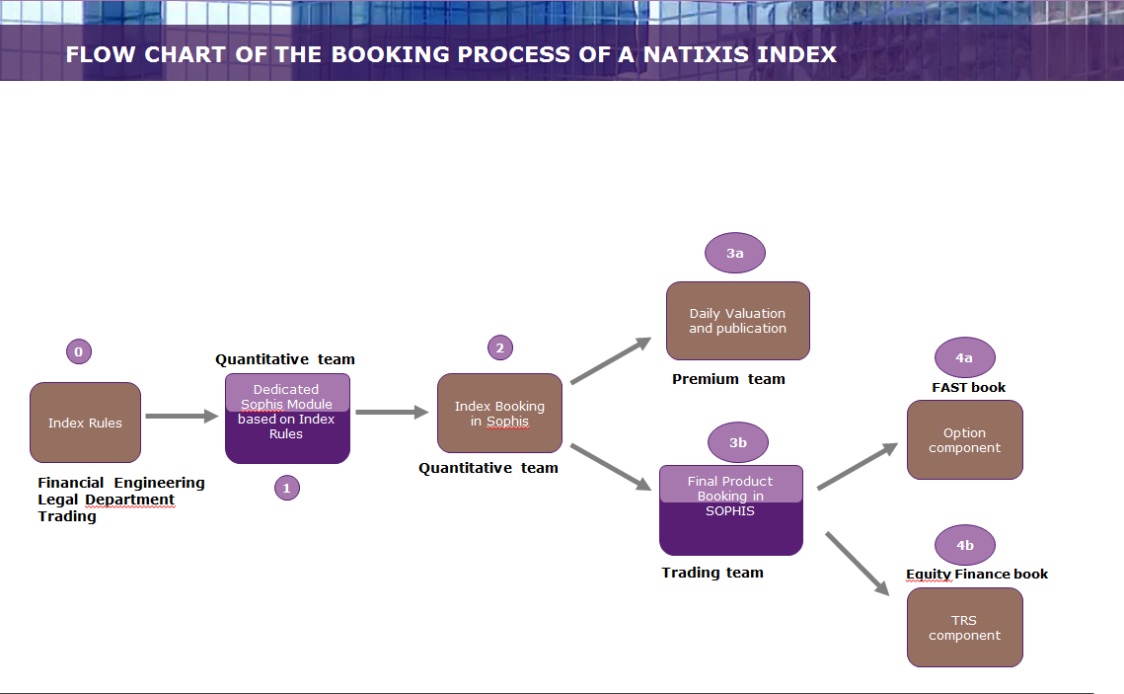

*Risk management.*

Thank’s to the NPC 09-30, Risk Mandate trading book have already been granted risk mandates in the context of booking transactions linked to rule based indices.

Our suggestion is to review or extend the risk mandates following the new FAST trading organisation

**Exhibit 1: Example of Bloomberg Page of Natixis Publication**

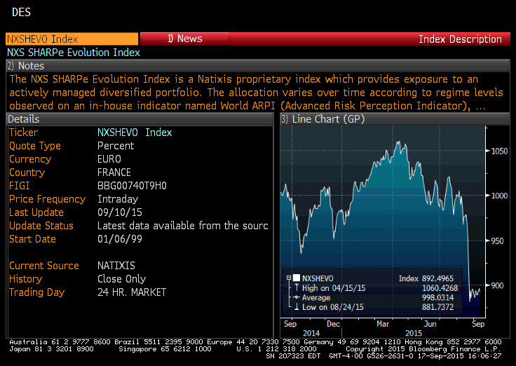

**Exhibit 2: Snapshot of the internal website dedicated to daily Natixis rule based index valuations**

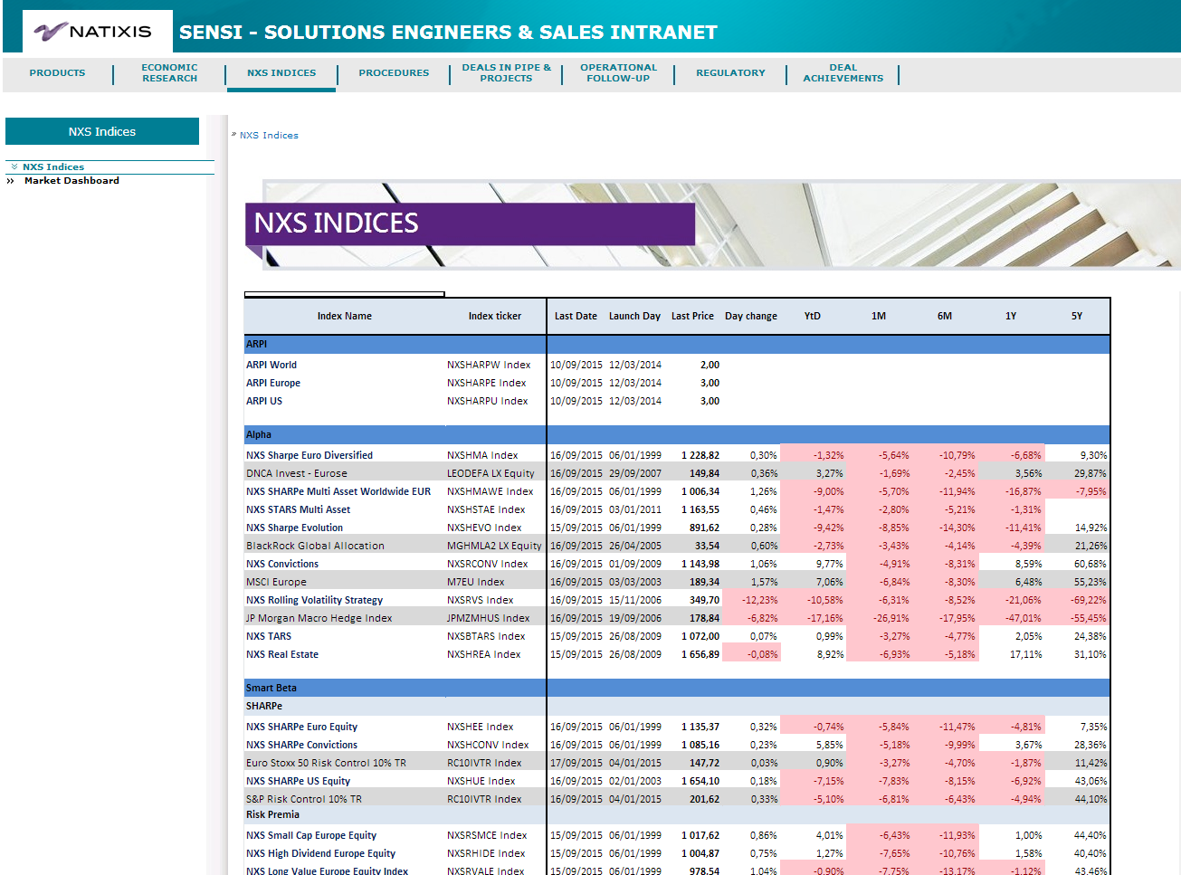

**Exhibit 3: Flow chart summary of current launching and booking process**

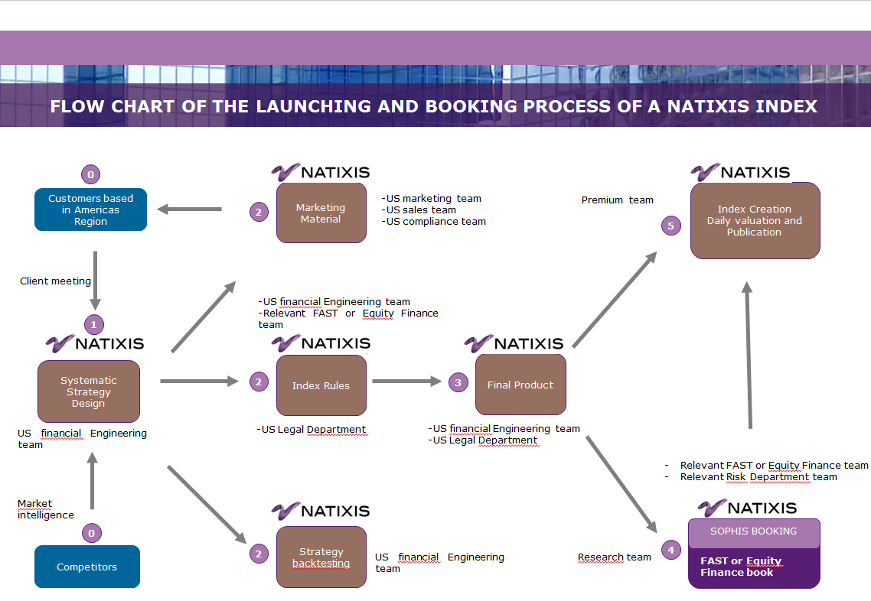

**Exhibit 4: Flow chart summary of future launching and booking process (After validation of Caesar Indice platform by Risk Department)**

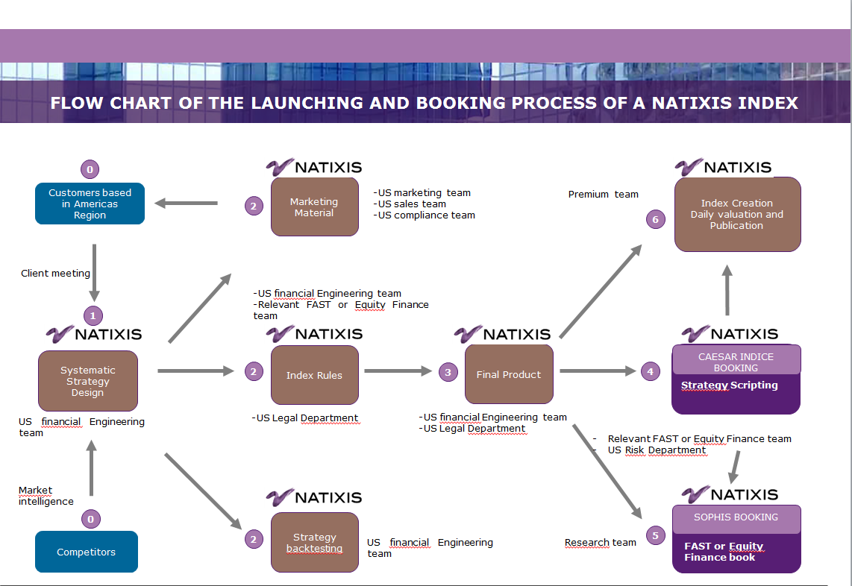

**Exhibit 5: “Springing Dealer Agreement” transaction linked to a BNP index with a US insurance company**

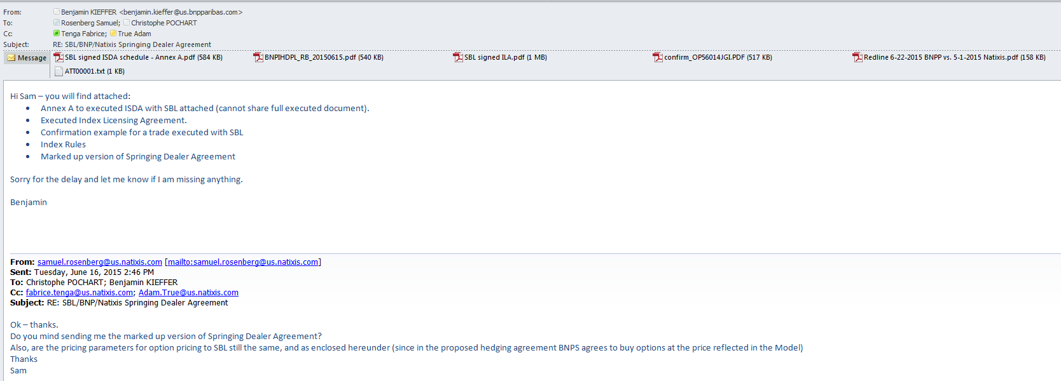

**Exhibit 6: Extract of Index rules of a Natixis rule based index**

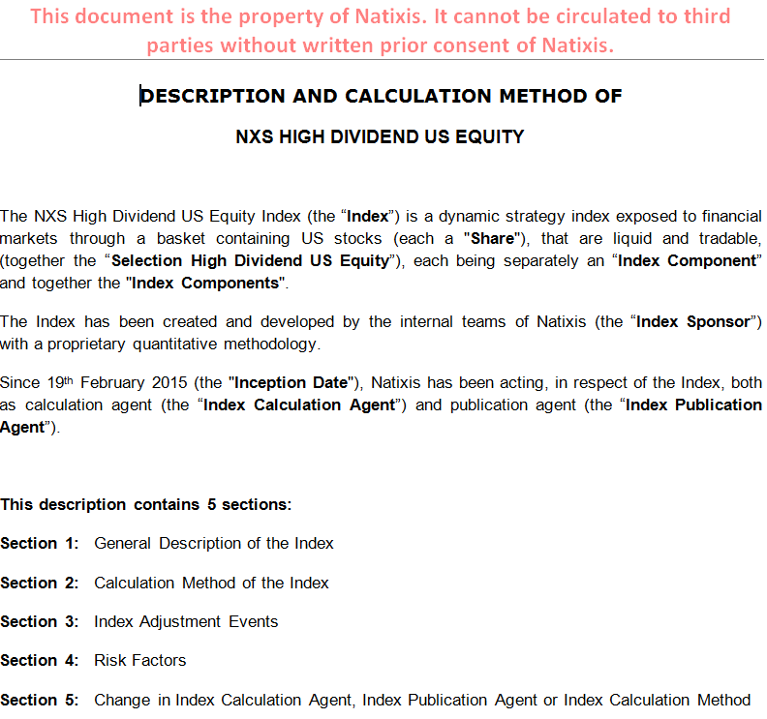

**Exhibit 7: Operational Procedure put in place in 2013 on EM Proprietary Index Setting up**

**EM proprietary index setting up**

|  |  |
| --- | --- |
| **Champ d’application** | **Propriétaire** |
| NATIXIS | Wholesale Banking WSB | WSB | EQUITY MARKETS | CLIENT TRADING | PRODUCTS STRUCTURING |
| **N° de version de la procédure** | **Code de la procédure** |
| 1.0 | C01.20.20-13 001 |

**Sommaire**

Accès au document 13

Visa des intervenants 13

Revue de la procédure 14

Rattachement au référentiel 14

Objectifs et exigences de la procédure 14

Périmètre couvert 15

Risques 15

Schéma Général 16

Description des tâches 17

# Accès au document

[**http://sharecib.intranet/sites/cartoprocess/fr/Pages/default.aspx**](http://sharecib.intranet/sites/cartoprocess/fr/Pages/default.aspx)

# Visa des intervenants

|  |  |
| --- | --- |
| **Valideur(s)** | **Rédacteur** |
| Frédéric GOASGUEN | WSB | EQUITY MARKETS | CLIENT TRADING | PRODUCTS STRUCTURING | WSB | Organisation WSB |
| **Date de validation Métier** | **Date du visa conformité** |
| 23/01/2013 | 06/11/2013 |

# Revue de la procédure

|  |  |
| --- | --- |
| **Dernière date d’actualisation** | Les procédures dont la date d’actualisation est supérieure de 2 ans à la date du jour sont potentiellement à revalider avec le Métier. |
| 23/01/2013 |

# Rattachement au référentiel

* **Processus :**
  + Proprietary index monitoring
* **Etape concernée :**
  + Proprietary index setting up

# Objectifs et exigences de la procédure

* **Object:**

Equity Markets develops, publishes and markets: a family of proprietary indices (for Natixis under the brand NXS), which includes innovative investment strategies aiming at capturing the absolute performance or optimizing the risk / return ratio.

These indices:  
- are made of liquid underlyings selected within a wide universe of assets and reallocated according to rules based on quantitative methodologies   
- can be directly invested  
- present characteristics of high liquidity, transparency and systematicity  
- can also be based on strategies aimed at generating outperformance and / or access to new market segments.

The NXS range enables investors to access to new asset classes providing diversification and optimization to their portfolios.

***Focus point(s):***

Ø

* **Impact réglementaire :**

# Périmètre couvert

* **Ligne(s) métier(s) concernée(s) :**
* EM_Equity markets
* **Localisation(s) :**
* PARIS – France
* PLATFORM - EMEA (Europe except France - Middle East - Africa)
* PLATFORM - APAC (Asia - Pacific)
* PLATFORM - AMERICA (North - Central - South)
* **Produit(s) :**
* Index
* EQUITY
* HYBRIDS
* Exchanged Traded Fund (ETF)
* Hedge Funds Structured Transactions
* **Critique pour Natixis :**
* Non primordial

# Risques

* **Non-compliance:**
* R-G020 Not ensuring that documents and information, including marketing materials, provided to clients are complete (notably as regards with risk disclosures, drawbacks and advantages of the product or transaction), fair, clear and not misleading
* R-G071 Not drawing up nor following pre-approval procedures for new products and activities, including not obtaining the opinion from the Compliance Department
* **Operational:**
* Standard risks linked to financial products

# Schéma Général

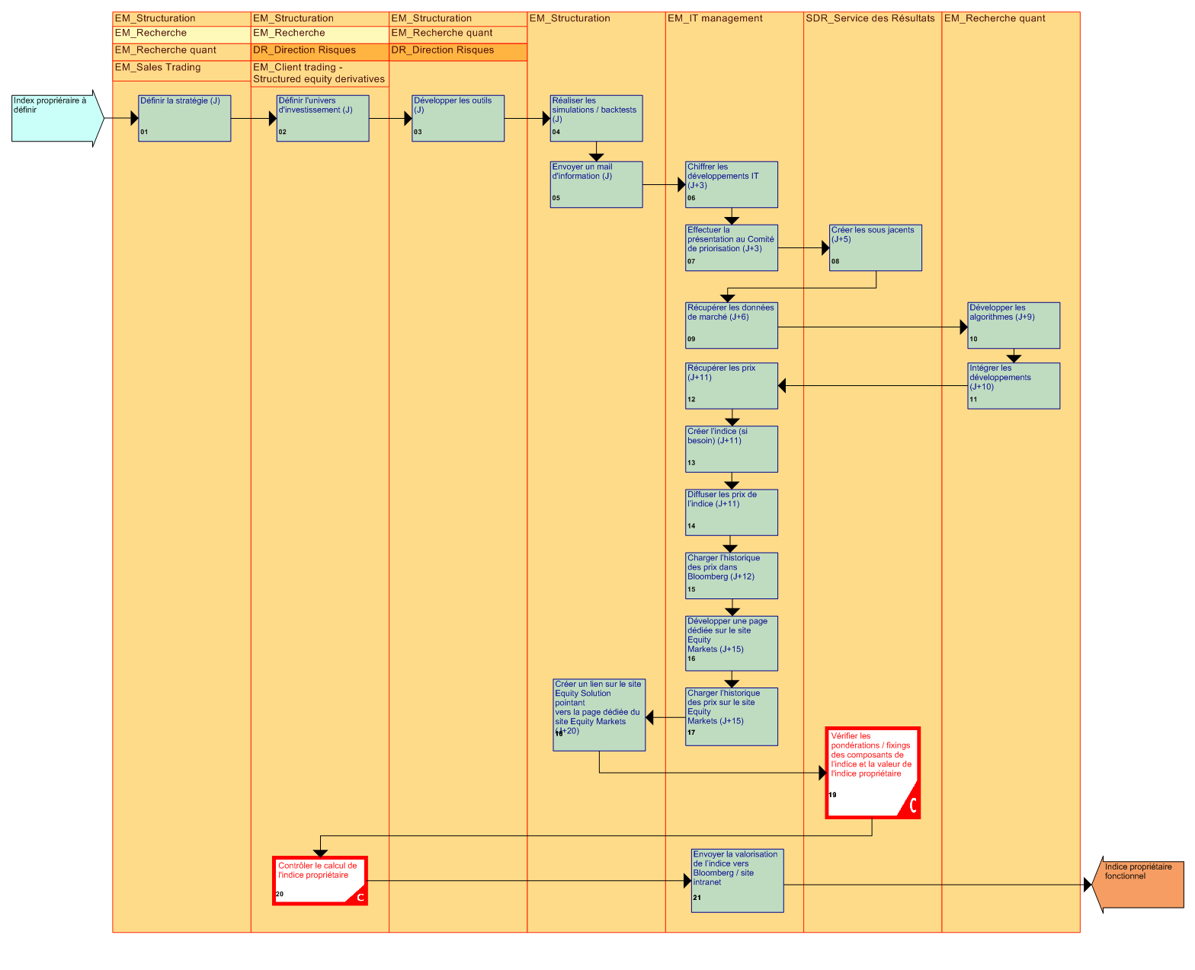

# Description des tâches

|  |  |
| --- | --- |
| 01 | Define the strategy (D) |
| *Acteur(s) :* | EM_Recherche  EM_Sales Trading  EM_Structuration  EM_Recherche quant |
| *Catégorie :* | Tâche |
| *Description :* | Define a management strategy for an asset portfolio meeting with an accurate client issue. |
| *Remarque(s) :* | Ø |
| *Outil(s) :* | MICROSOFT - Outlook |
| *Contrôle :* | Ø |

|  |  |
| --- | --- |
| 02 | Define the investment universe (D) |
| *Acteur(s) :* | DR_Direction Risques  EM_Client trading - Structured equity derivatives  EM_Recherche  EM_Structuration |
| *Catégorie :* | Tâche |
| *Description :* | Choose underlyings complying with investment criteria of the strategy. |
| *Remarque(s) :* | Ø |
| *Outil(s) :* | MICROSOFT - Excel  MICROSOFT - Outlook |
| *Contrôle :* | Ø |

|  |  |
| --- | --- |
| 03 | Develop tools (D) |
| *Acteur(s) :* | DR_Direction Risques  EM_Structuration  EM_Recherche quant |
| *Catégorie :* | Tâche |
| *Description :* | Develop algorithms to calibrate the strategy from simulations. |

|  |  |
| --- | --- |
| *Remarque(s) :* | Ø |
| *Outil(s) :* | MICROSOFT - Excel |
| *Contrôle :* | Ø |

|  |  |
| --- | --- |
| 04 | Perform simulations / backtests (D) |
| *Acteur(s) :* | EM_Structuration |
| *Catégorie :* | Tâche |
| *Description :* | From developed tools, perform tests to validate or not the defined strategy. |
| *Remarque(s) :* | Ø |
| *Outil(s) :* | MICROSOFT - Excel |
| *Contrôle :* | Ø |

|  |  |
| --- | --- |
| 05 | Send an email for information (D) |
| *Acteur(s) :* | EM_Structuration |
| *Catégorie :* | Tâche |
| *Description :* | Inform each player impacted that the strategy is valid and that it is going to be spread, to mobilize them on tasks to come. |
| *Remarque(s) :* | Ø |
| *Outil(s) :* | MICROSOFT - Outlook |
| *Contrôle :* | Ø |

|  |  |
| --- | --- |
| 06 | Quantify IT developments (D+3) |
| *Acteur(s) :* | EM_IT management |
| *Catégorie :* | Tâche |
| *Description :* | Quantify IT development costs (in m/d) according to the defined strategy. |
| *Remarque(s) :* | Ø |
| *Outil(s) :* | MICROSOFT - Outlook |
| *Contrôle :* | Ø |

|  |  |
| --- | --- |
| 07 | Present to the priorization committee (D+3) |
| *Acteur(s) :* | EM_IT management |
| *Catégorie :* | Tâche |
| *Description :* | In case of development, record the request to the IT Committee. |
| *Remarque(s) :* | Ø |
| *Outil(s) :* | MICROSOFT - Outlook |
| *Contrôle :* | Ø |

|  |  |
| --- | --- |
| 08 | Create underlyings (D+5) |
| *Acteur(s) :* | SDR_Service des Résultats |
| *Catégorie :* | Tâche |
| *Description :* | Have the reference of underlying components of the index created by SDR (if they are not referenced). |
| *Remarque(s) :* | Ø |
| *Outil(s) :* | SOPHIS |
| *Contrôle :* | Ø |

|  |  |
| --- | --- |
| 09 | Retrieve market data (D+6) |
| *Acteur(s) :* | EM_IT management |
| *Catégorie :* | Tâche |
| *Description :* | Ensure that the used underlyings get the right market values. |
| *Remarque(s) :* | Ø |
| *Outil(s) :* | BLOOMBERG |
| *Contrôle :* | Ø |

|  |  |
| --- | --- |
| 10 | Develop algorithms (D+9) |
| *Acteur(s) :* | EM_Recherche quant |
| *Catégorie :* | Tâche |
| *Description :* | Develop the formula for computing the index within Sophis format. |

|  |  |
| --- | --- |
| *Remarque(s) :* | Ø |
| *Outil(s) :* | SOPHIS |
| *Contrôle :* | Ø |

|  |  |
| --- | --- |
| 11 | Incorporate developments (D+10) |
| *Acteur(s) :* | EM_Recherche quant |
| *Catégorie :* | Tâche |
| *Description :* | Implement the « library » within the toolkit. |
| *Remarque(s) :* | Ø |
| *Outil(s) :* | SOPHIS  TOOL KIT |
| *Contrôle :* | Ø |

|  |  |
| --- | --- |
| 12 | Retrieve prices (D+11) |
| *Acteur(s) :* | EM_IT management |
| *Catégorie :* | Tâche |
| *Description :* | Test the existence and the accuracy of underlying prices. |
| *Remarque(s) :* | Ø |
| *Outil(s) :* | BLOOMBERG  VIP K2 |
| *Contrôle :* | Ø |

|  |  |
| --- | --- |
| 13 | Create the index (if necessary) (D+11) |
| *Acteur(s) :* | EM_IT management |
| *Catégorie :* | Tâche |
| *Description :* | Inform Bloomberg about the creation of a new index providing them with the determined ticker. |
| *Remarque(s) :* | Ø |
| *Outil(s) :* | BLOOMBERG  MICROSOFT - Outlook |

|  |  |
| --- | --- |
| *Contrôle :* | Ø |

|  |  |
| --- | --- |
| 14 | Provide index prices (D+11) |
| *Acteur(s) :* | EM_IT management |
| *Catégorie :* | Tâche |
| *Description :* | Provide Bloomberg with prices computed by Sophis via VIP K2. |
| *Remarque(s) :* | Ø |
| *Outil(s) :* | BLOOMBERG  VIP K2 |
| *Contrôle :* | Ø |

|  |  |
| --- | --- |
| 15 | Load price records within Bloomberg (D+12) |
| *Acteur(s) :* | EM_IT management |
| *Catégorie :* | Tâche |
| *Description :* | Send Bloomberg back tests values in order to display information on the screen so that it is accessible by all clients. |
| *Remarque(s) :* | Ø |
| *Outil(s) :* | BLOOMBERG  MICROSOFT - Excel  MICROSOFT - Outlook |
| *Contrôle :* | Ø |

|  |  |
| --- | --- |
| 16 | Develop a dedicated page on Equity Markets website (D+15) |
| *Acteur(s) :* | EM_IT management |
| *Catégorie :* | Tâche |
| *Description :* | If necessary, create a new page dedicated to this index, on the Equity Markets website. |
| *Remarque(s) :* | Ø |
| *Outil(s) :* | NATIXIS Intranet |
| *Contrôle :* | Ø |

|  |  |
| --- | --- |
| 17 | Load price records on the Equity website (D+15) |
| *Acteur(s) :* | EM_IT management |
| *Catégorie :* | Tâche |
| *Description :* | Send the back tests values. |
| *Remarque(s) :* | Ø |
| *Outil(s) :* | NATIXIS Intranet |
| *Contrôle :* | Ø |

|  |  |
| --- | --- |
| 18 | Create a link on the Equity Solution website that points towards a dedicated page of the Equity Markets website (D+20) |
| *Acteur(s) :* | EM_Structuration |
| *Catégorie :* | Tâche |
| *Description :* | Create a link for the new index indicating that the information is available on the Equity Solutions website. |
| *Remarque(s) :* | Ø |
| *Outil(s) :* | NATIXIS Intranet |
| *Contrôle :* | Ø |

|  |  |
| --- | --- |
| 19 | Check index components’ weightings / fixings and the value of the proprietary index |
| *Acteur(s) :* | SDR_Service des Résultats |
| *Catégorie :* | Tâche de contrôle |
| *Description :* | The role of SDR is to enable the algorithm to run within Sophis:  - entry of weight given by the algorithm,  - check the correct running of the algorithm. An automaton calculates the weighting according to objective and market observables (index closing, spots fixing...). |
| *Remarque(s) :* | Ø |
| *Outil(s) :* | SOPHIS |
| *Contrôle :* | Ø |

|  |  |
| --- | --- |
| 20 | Check the computation of the proprietary owner |

|  |  |
| --- | --- |
| *Acteur(s) :* | DR_Direction Risques  EM_Client trading - Structured equity derivatives  EM_Recherche  EM_Structuration |
| *Catégorie :* | Tâche de contrôle |
| *Description :* | Controls on indices are made ​​by concerned desks. |
| *Remarque(s) :* | Ø |
| *Outil(s) :* | MICROSOFT - Excel  MICROSOFT - Outlook  SOPHIS |
| *Contrôle :* | Ø |

|  |  |
| --- | --- |
| 21 | Send index value to Bloomberg / intranet website |
| *Acteur(s) :* | EM_IT management |
| *Catégorie :* | Tâche |
| *Description :* | The index value is daily provided. |
| *Remarque(s) :* | Ø |
| *Outil(s) :* | VIP K2 |
| *Contrôle :* | Ø |

**Exhibit 8: Exemple of a Term sheet of an OTC option linked to a Natixis rule based index**



**Equity Markets**

[DATE]

|  |
| --- |
| **FRONT OFFICE PRECONFIRMATION**  We hereby would like to pre-confirm the terms & conditions as agreed today.  An official confirmation will be sent by our Back Office. The following details apply: |

|  |  |
| --- | --- |
| **OTC European Call Option on NXS Optimum Asia Index** | |
| Trade Date: | [TBD] |
| Option Style: | European |
| Option Type: | Call |
| Seller: | Natixis |
| Buyer: | [TBD] |
| Index: | |  |  | | --- | --- | | **Index** | **Bloomberg Ticker** | | NXS Optimum Asia Index | [NXSHOPTA Index] | |
| Notional Amount (“NA”) | [TBD] |
| Strike Price: | [ …]/[ Means the closing level of the Index as determined by the Calculation Agent on the Strike Date][1] |
| Strike Date : | [TBD] [provided that:   1. If the Strike Date is not a Scheduled Trading Day in respect of an Index, then the Strike Date in respect of that Index shall be the next following Scheduled Trading Day, and 2. If the Strike Date is a Disrupted Day in respect of an Index, then Section 6.6 of the Equity Definitions shall apply to such date as if it was a Valuation Date][2] |
| Premium: | [TBD] |
| Premium Payment Date: | [TBD] |
| Exchange: | In respect of each component security of the Index (« each a “Component Security”), the principal stock exchange on which such Component Security is principally traded, as determined by the Calculation Agent. |
| Related Exchange |  |
| **Procedure for Exercise** |  |
| Automatic Exercise: | Applicable |
| Expiration Time: | The time at which the official closing level of the Index is calculated and published by the Index Sponsor on the Expiration Date |
| Expiration Date: | [TBD] |
| **Valuation** |  |
| Valuation Time: | For the purpose of this Transaction, means : (i) for the purpose of determining whether a Market Disruption Event has occurred: (a) in respect of any Component Security, the Scheduled Closing Time on the Exchange in respect of such Component Security, and (b) in respect of any option contracts or future contracts on the Index, the close of trading on the Related Exchange; and (ii) in all other circumstances, the time at which the official closing level of the Index is calculated and published by the Index Sponsor. |
| Valuation Date: | The Exercise Date |
| **Settlement Provisions** |  |
| Cash Settlement: | Applicable |
| Settlement Currency: | EUR |
| Settlement Price: | Means the level of the Index on the Valuation Date as determined by the Calculation Agent at the Valuation Date |
| Cash Settlement Payment Date: | […][3]/ [TBD[4]] Currency Business Days following the Valuation Date. |
| Option Cash Settlement Amount : | Means an amount determined by the Calculation Agent on the Valuation Date equal to:  NA * Participation *Max ( -10%;  - 1) |
| Participation | 100% |
|  |  |
| Consequence of Averaging Date Disruption: | Modified Postponement |
| **Exchange Business Day:** | Any Scheduled Trading Day on which: (i) the Index Sponsor publishes the level of the Index; and (ii) the Related Exchange is open for trading during its regular trading session, notwithstanding any Exchange or the Related Exchange closing prior to its Scheduled Closing Time. |
| **Scheduled Trading Day:** | Any day on which: (i) the Index Sponsor is scheduled to publish the level of the Index; and (ii) the Related Exchange is scheduled to be open for trading for its regular trading session. |
| **Documentation:** | The Transaction shall be governed by ISDA Master Agreement, the 2002 ISDA Equity Derivatives Definitions (the “Equity Definitions”) |
| **Calculation Agent:** | Natixis |
| **RIC:** | [ …] |
| **Governing Law:** | English Law |
| **Index Adjustment Events:** | Calculation Agent Adjustment |
| **Additional Disruption Events:** |  |
| Change in Law: | Applicable, provided, however, that paragraph (X) of Section 12.9 (a)(ii) of the Equity Definitions is amended by the replacement of the word “Shares” with “Hedge Positions” |
| Determining Party: | Natixis |
| **Representations:** |  |
| Non reliance, Agreements and Acknowledgments Regarding Hedging Activities, Index Disclaimer, Additional Acknowledgments | Applicable |
| **Market Disruption Event:** | For the purpose of this transaction, means either:  (i)(a) the occurrence or existence, in respect of any Component Security, of:  (1) a Trading Disruption in respect of such Component Security, which the Calculation Agent determines is material, at any time during the one hour period that ends at the relevant Valuation Time in respect of the Exchange on which such Component Security is principally traded;  (2) an Exchange Disruption in respect of such Component Security, which the Calculation Agent determines is material, at any time during the one hour period that ends at the relevant Valuation Time in respect of the Exchange on which such Component Security is principally traded; OR  (3) an Early Closure in respect of such Component Security; AND  (b) the aggregate of all Component Securities in respect of which a Trading Disruption, an Exchange Disruption or an Early Closure occurs or exists comprises 20 per cent. or more of the level of the Index; OR  (ii) the occurrence or existence, in respect of futures or options contracts relating to the Index, of: (a) a Trading Disruption Event; (b) an Exchange Disruption, which in either case the Calculation Agent determines is material, at any time during the one hour period that ends at the Valuation Time in respect of the Related Exchange; or (c) an Early Closure, in each case in respect of such futures or options contracts.  For the purposes of determining whether a Market Disruption Event exists in respect of a Component Security at any time, if a Market Disruption Event occurs in respect of such Component Security at that time, then the relevant percentage contribution of that Component Security to the level of the Index shall be based on a comparison of (x) the portion of the level of the Index attributable to that Component Security to (y) the overall level of the Index, in each case using the official opening weightings as published by the Index Sponsor as part of the market "opening data". |
| Trading Disruption: | For the purposes of this Transaction, means any suspension of or limitation imposed on trading by the relevant Exchange or Related Exchange or otherwise and whether by reason of movements in price exceeding limits permitted by the relevant Exchange or Related Exchange or otherwise: (i) relating to any Component Security on the Exchange in respect of such Component Security; or (ii) in futures or options contracts relating to the Index on the Related Exchange. |
| Exchange Disruption: | For the purposes of this Transaction, means any event (other than an Early Closure) that disrupts or impairs (as determined by the Calculation Agent) the ability of market participants in general to effect transactions in, or obtain market values for: (i) any Component Security on the Exchange in respect of such Component Security; or (ii) futures or options contracts relating to the Index on the Related Exchange. |
| Early Closure: | For the purposes of this Transaction, means the closure on any Exchange Business Day of the Exchange in respect of any Component Security or the Related Exchange prior to its Scheduled Closing Time unless such earlier closing is announced by such Exchange or Related Exchange (as the case may be) at least one hour prior to the earlier of: (i) the actual closing time for the regular trading session on such Exchange or Related Exchange (as the case may be) on such Exchange Business Day; and (ii) the submission deadline for orders to be entered into the Exchange or Related Exchange system for execution at the relevant Valuation Time on such Exchange Business Day. |
| Disrupted Day: | For the purposes of this Transaction, means any Scheduled Trading Day on which: (i) the Index Sponsor fails to publish the level of the Index; (ii) the Related Exchange fails to open for trading during its regular trading session; or (iii) a Market Disruption Event has occurred. The Calculation Agent shall as soon as reasonably practicable under the circumstances notify the parties or other party, as the case may be, of the occurrence of a Disrupted Day on any day that, but for the occurrence of a Disrupted Day, would have been an Averaging Date, a Valuation Date, a Potential Exercise Date, a Knock-in Determination Day, a Knock-out Determination Day or an Expiration Date. Without limiting the obligation of the Calculation Agent to notify the parties as set forth in the preceding sentence, failure by the Calculation Agent to notify the parties of the occurrence of a Disrupted Day shall not affect the validity of the occurrence and effect of such Disrupted Day on this Transaction. |

|  |  |
| --- | --- |
| Contacts |  |
| *NATIXIS Back Office* |  |
| Name : |  |
| Tel : |  |
| Email : |  |
| *NATIXIS Front Office* |  |
| Name : |  |
| Email / Tel : |  |
|  |  |
| *Client Front Office* |  |
| Name: | [ …] |
| Email / Tel: | [ …] |
| *Client Back Office* |  |
| SSI: | [ …] |
| Name: | [ …] |
| Email / Tel: | [ …]/[ …] |

This term sheet is a highly confidential document, the property of Natixis and should not be transmitted to any person other than its original addressee(s) without the prior written consent of Natixis.

The distribution, possession or delivery of this document in, to or from certain jurisdictions may be restricted or prohibited by law. Recipients of this document are therefore required to ensure that they are aware of, and comply with, such restrictions or prohibitions. Neither Natixis, nor any of its affiliates, directors, employees, agents or advisers nor any other person accepts any liability to anyone in relation to the distribution, possession or delivery of this document in, to or from any jurisdiction.

This document is communicated to the recipient for information purposes only and does not constitute a personalised recommendation. The products or services described herein do not take into account any specific investment objective, financial situation or particular need of any particular recipient. Any undertaking is subject to a formal approval by Natixis in accordance with its current internal procedures.

The information contained in this document does not take into account specific tax rules or accounting methods applicable to counterparties, clients or potential clients of Natixis.

Natixis shall not be liable for any financial loss or any decision taken on the basis of the information contained in this document and Natixis does not hold itself out as providing any advice, particularly in relation to investment services. In any event, you should request for any internal and/or external advice that you consider necessary or desirable to obtain, including from any financial, legal, tax or accounting advisor, or any other specialist advice, in order to verify in particular that the investment(s) described in this document meets your investments objectives and constraints, and to obtain an independent valuation of such investment(s), its risks factors and rewards.

Natixis is authorised in France by the Autorité de contrôle prudentiel et de résolution (“ACPR”)  as a Bank – Investment Services Provider and subject to its supervision. Natixis is regulated by the Autorité des marchés financiers (“AMF”) in respect of its investment services activities.

In the UK, Natixis is authorised by the ACPR and subject to limited regulation by the Financial Conduct Authority and Prudential Regulation Authority.  Details about the extent of our regulation by the Financial Conduct Authority and Prudential Regulation Authority are available from us on request.

Natixis is authorised by the ACPR and regulated by the BaFin (Bundesanstalt für Finanzdienstleistungsaufsicht) for the conduct of its business under the right of establishment in Germany.

Natixis is authorised by the ACPR and regulated by Bank of Spain and the CNMV for the conduct of its business under the right of establishment in Spain.

Natixis is authorised by the ACPR and regulated by Bank of Italy and the CONSOB (Commissione Nazionale per le Società e la Borsa) for the conduct of its business under the right of establishment in Italy.

Natixis is authorised by the ACPR and regulated by the Dubai Financial Services Authority (DFSA) for the conduct of its business in and from the Dubai International Financial Centre (DIFC). The document is being made available to the recipient with the understanding that it meets the DFSA definition of a Professional Client; the recipient is otherwise required to inform Natixis if this is not the case and return the document. The recipient also acknowledges and understands that neither the document nor its contents have been approved, licensed by or registered with any regulatory body or governmental agency in the GCC or Lebanon.

Natixis is regulated throughout the European Union on a crossborder basis.

***Exhibit 8: Exemple of Sophis Booking of a rule based Index booked for valuation purposes only (No related transaction)***

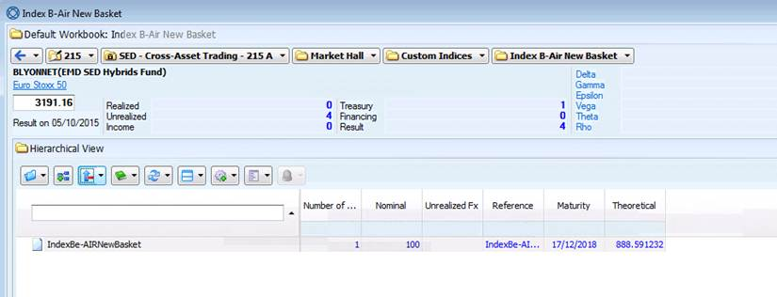

***Exhibit 9: Exemple of Sophis Booking of a rule based Index as a “realized” of the option (Millesime Excellence 1)***

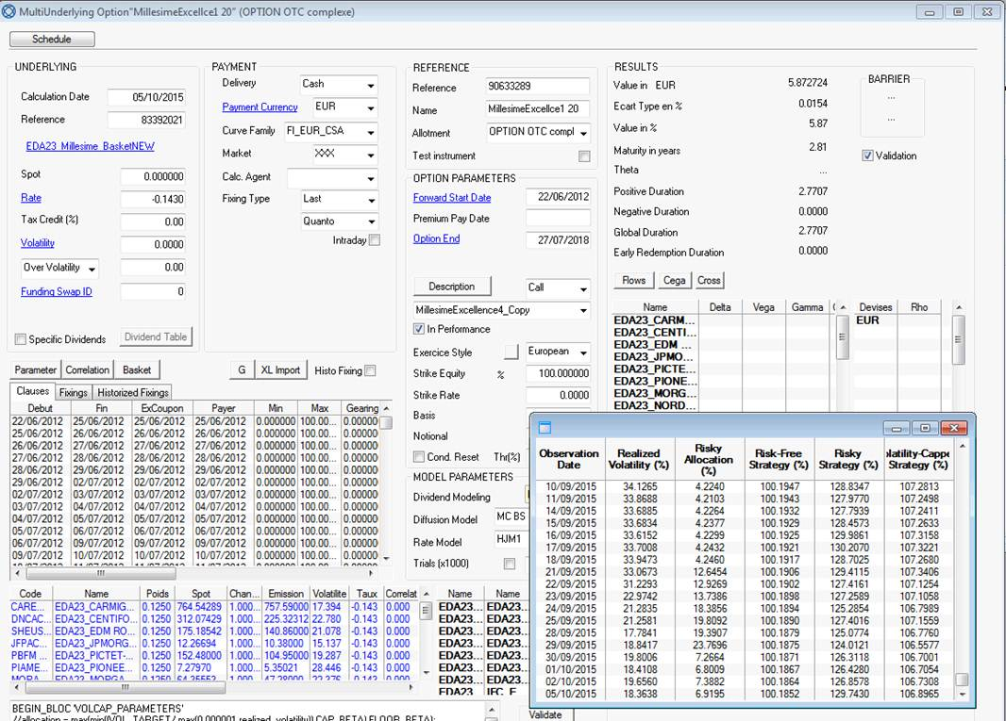

***Exhibit 10: Exemple of Sophis Booking of a rule based Index through a dedicated IT module that fuels the Index value inside the related option (Optimal Europe)***

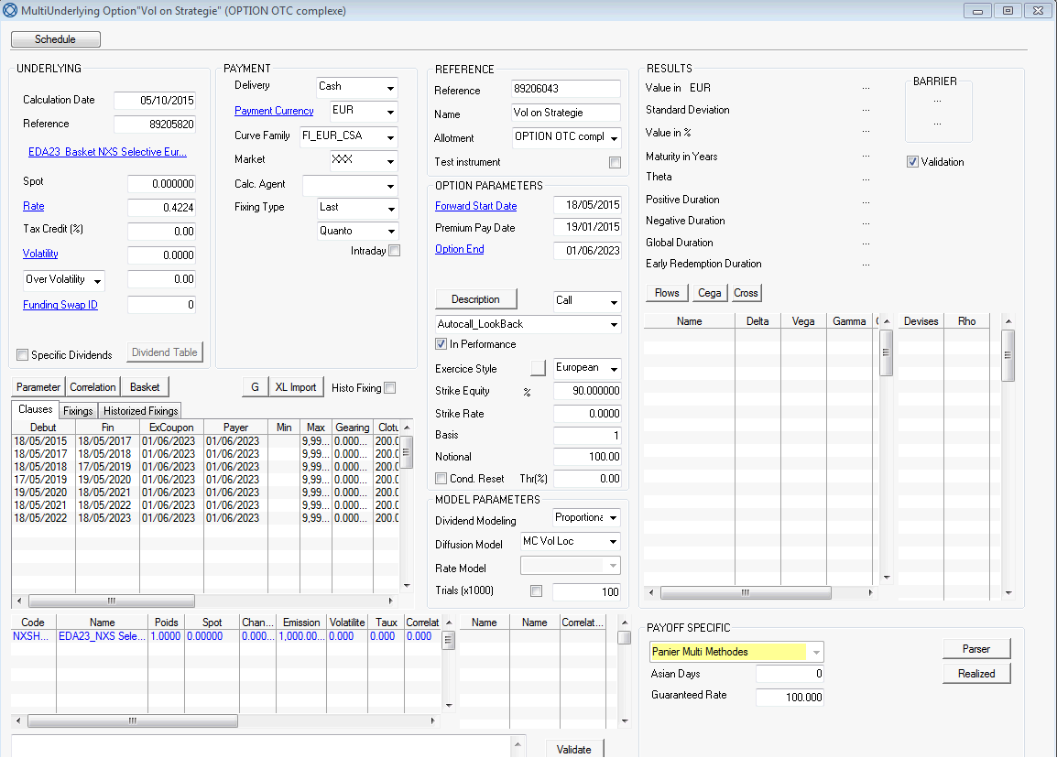

1. Delete if the Strike Price of the Index is known at the Trade Date
2. Delete if the Strike Price of the Index is known at the Trade Date
3. Insert Date if known
4. Indicate the relevant period of CBD necessary and if there are more than one Exchange, the longest period.